Larysa Kuzmenko is a Toronto-based composer, pianist and Juno nominee.  Her music has been commissioned, performed, broadcast and recorded by many outstanding musicians all over the world.  She has appeared as a pianist in several countries, and has performed at Carnegie Hall, St. Lawrence Centre, England, USA, Roy Thomson Hall, Massey Hall and several other Canadian venues.  She is currently on staff at the University of Toronto's Faculty of Music, where she teaches piano, harmony, and composition.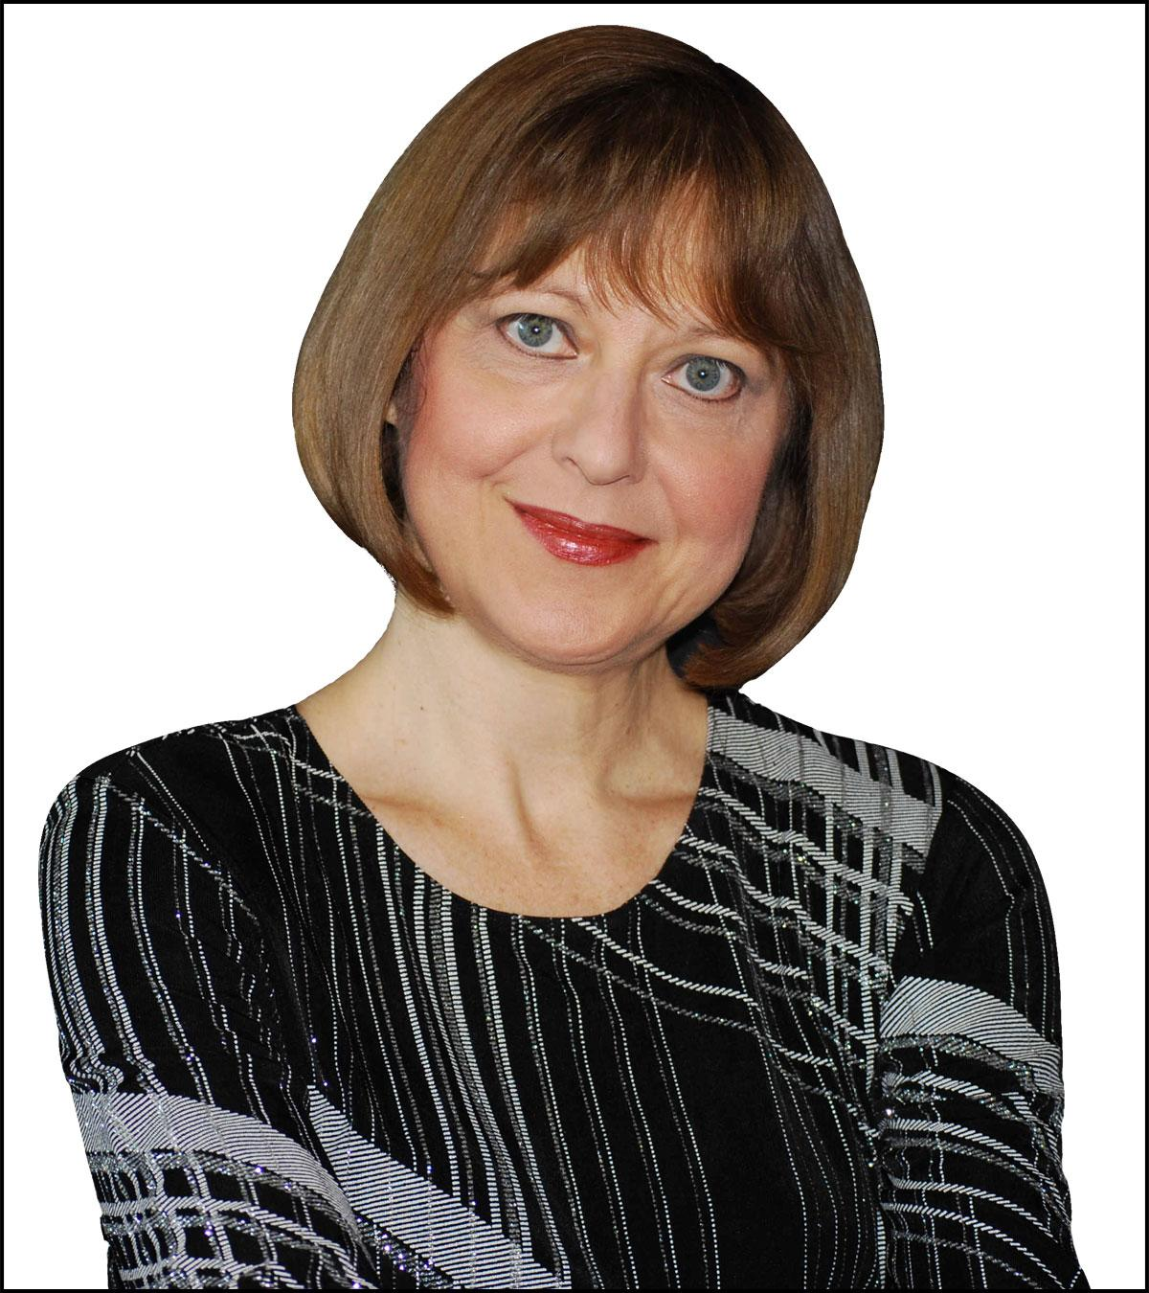

Her works demonstrate a strong affinity towards the mainstream of classical music.  She imbues her music with a strong melodic sense, and a firm rooting in traditional, albeit extended tonal processes.  She has been awarded commissions from the Ontario Arts Council, CBC, Laidlaw foundation, and from private commissioners.  She was a composer in residence at the Memorial University in Newfoundland in 2010. Her music is published by Boosey and Hawkes, Plangere, and Frederic Harris.  Her solo piano works "In Memoriam to the Victims of Chernobyl" and "Mysterious Summer's Night" have become standard repertoire for pianists.  These pieces receive over a hundred performances a year.  Her choral works "Winds” and “Stars" are performed regularly all over the world with sales of over a thousand copies a year.

In 2011, Larysa received a Juno nomination for her "Piano Concerto" which was recorded on CD by well-known Ukrainian Canadian pianist Christina Petrowska Quilico. Most recently, she was commissioned, through a grant from the Ontario Arts Council, to write a work for the Toronto Symphony's 90th anniversary.  This work, "Behold the Night" was composed for the Toronto Symphony Orchestra and the Toronto Children's Choir. It was extremely well received by the audience and was broadcast on CBC.  Oscar winner Christopher Plummer was on the same show as the premiere of "Behold the Night".  During the after show dinner, he told the composer that "Shakespeare would have been very proud of Larysa Kuzmenko's musical setting of the text to ‘A Midsummer's Night Dream’”. Critic Colin Eatock from the Globe and Mail wrote, "The work is as charming and colourful as any film score by Danny Elfman or John Williams".

Some prominent ensembles and soloists who have performed her works include, the Toronto Symphony Orchestra, directed by Peter Oundjian and Jukka-Pekka Saraste, Winnipeg Symphony Orchestra directed by Bramwell Tovey, Thunder Bay Orchestra directed by Jeoffrey Moule, Gryphon Trio, Composer's Orchestra directed by Gary Kulesha, cellists Shauna Rolston, Kristine Bogyo, and Kaori Yamagami, pianists Anton Kuerti and Andrew Burashko, the Elmer Esler Singers, and the Elora Festival Singers just to name a few.

“Behold the Night” for children's chorus and full orchestra. Performed by the Calgary Symphony Orchestra on September 28 and 29, 2018 in Jack Singer Hall, Calgary. Performed by the Cantare Children's Choir and conducted by Rune Bergmann.

“Trade Song” for violin, viola, cello, guitar, spoons and full orchestra was premiered on October 18, 2019, in the Community Auditorium, Thunder Bay. Performed by the Metis Quartet and the Thunder Bay Symphony Orchestra. Conducted by Paul Haas.

“Voice of Hope” for soprano and string orchestra. This version was arranged for piano trio. Performed on October 28, 2018 at the Runnymede United Church. Performed by mezzo soprano Katerina Tchoubar and the Gryphon Trio.

“Suite of Dances” for flute, cello and piano performed at the Memorial University of Newfoundland on November 15, 2018. Performed by the Trinitas Chamber Ensemble. Flute: Michelle Cheramy, Cello: Nathan Cook, Piano: Phil Roberts.

“Holy God” for SATB a cappella. Commissioned and premiered by the St. Lawrence Choir on November 17, 2018 at the Saint Sophie Ukrainian Orthodox Church, Montreal. Conducted by Philippe Bourque.

“Piano Concerto” for piano and full orchestra. Performed on March 2, 2019 in Festival Hall, Pembroke, with pianist Christina Petrowska-Quilico. Conducted by Mehdi Javanfar.

“One Sister Have I” for Women's Chorus. Performed on March 24, 2019, at the Faculty of Music, Toronto, in the MacMillan Theatre. Performed by the University of Toronto Women's Chamber Choir. Conducted by Dr. Lori-Anne Dolloff.

“Daffodils” for solo violin and piano. Premiered on June 21, 2019 by violinist Ralista Tcholakova at the Alpha Art Gallery in Ottawa.

“Skartaris” double concerto for solo violin, solo piano and string orchestra. Premiered on November 8, 2019 at the Glenn Gould studio. Performed by violinist Marc Djokic, pianist Christina Petrowska Quilico and Sinfonia Toronto under the direction of Nurhan Arman

“Fantasy on a theme by Beethoven” for orchestra. Premiered on February 14, 2020 at the Taylor Centre for the performing Arts in Calgary. Performed by the Calgary Philharmonic Orchestra. Conducted by Rune Bergmann.

“Stars,Wind and Night” for children's chorus performed on February 23, 2020 by the Toronto Children's Chorus at the Earl Haig School. Directed by Matthew Otto.

New works completed: “Holy God”for SATB a cappella chorus.

Ms. Kuzmenko is currently on staff at the University of Toronto's Faculty of Music, where she teaches piano, harmony, and composition.

Larysa Kuzmenko is married to Canadian composer/pianist/conductor Gary Kulesha.